# CREATE A SERVICE CALL - STANDARD

**ACCESS EQUIPMENT REPAIR LABOUR GUIDELINES (ERLG)**

## Introduction

Late in 2017, CAT made a few changes to the way you access ERLGs; you now need to go via the service data webpage. The easiest way to get to ERLGs is through the NAXT Quick Link you’d have set up for labour guidelines.

If you don’t have a labour guideline quick link, it’s easy to set up. Or, if your labour guideline seems broken, you can easily check and amend the web address to the correct one (<https://dealer.cat.com/en/ps/service/trg.html>). Click [here](http://intra/files/qrg---create-and-manage-naxt-quick-links-pdf-KGXHq9.pdf) for the NAXT quick link QRG.

## STEPS

**Step 1: Navigate to your NAXT home page; access CWS**

1A: Select the ‘Home’ icon. On the right hand side of this display you should see ‘Quick links’.

1B: Select the link that is for labour guidelines (*the display name is customisable, so your link may not be called the same as shown below*).

1C: The CWS page will open in a new window.

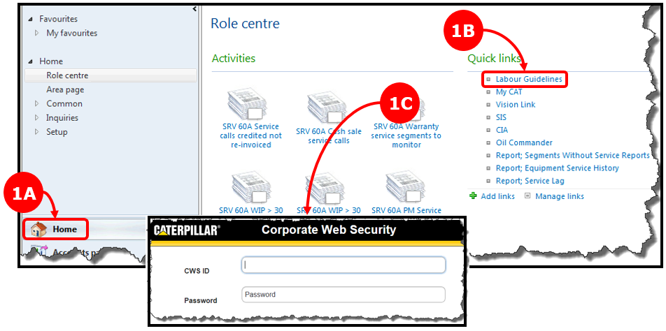

**Step 2: Access the Service Data website**

2A: Enter your credentials at the CWS login; the TRG page will display.

2B: Select the ‘ERLG’ link under ‘Related Links’;

2C: The Service Data window will open.

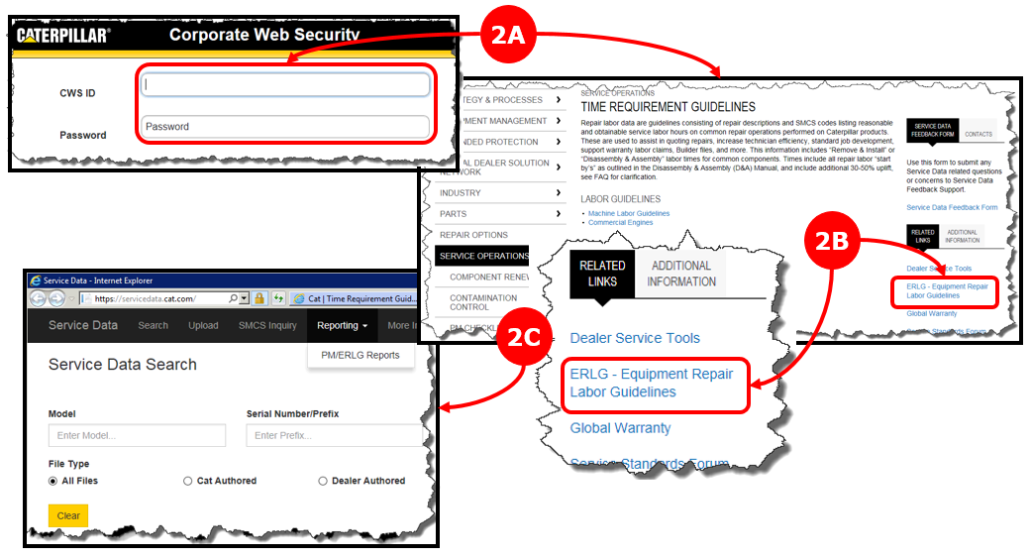

**Step 3: Choose your equipment**

3A: Select ‘Reporting’ and then the ‘PM/ELRG Reports’ option.

3B: The Service Data Reporting screen will display.

3C: Select the ‘ELRG’ option.

3D: Enter the model you’re in the ‘Model’ field then select it from the options that show.

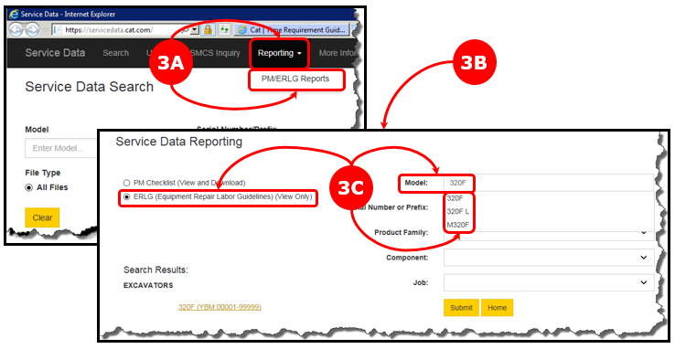

**Step 4: Select your equipment**

Select the search result link. The Search Results screen will display the ERLG for your equipment.

